“ Workforce Intelligence Report ”

HR ANALYSIS

Empowering HR Decisions with SQL: A Deep Dive into Workforce Trends & Retirement Readiness



OVER VIEW

This project aims to utilize SQL to explore and analyse workforce data for an organization. The goal is to derive actionable insights that assist HR professionals in making strategic decisions around **employee retention, retirement planning, satisfaction, performance, and hiring readiness**.The insights gained from this analysis support proactive HR strategies such as identifying employees nearing retirement, assessing performance-to-reward alignment, spotting attrition risks, and forecasting future workforce gaps. This data-driven approach empowers the HR team to move from reactive decision-making to predictive and strategic workforce management.

**(Power Query + SQL Integrated project)**

**_ANAMIKA K_**

EMPLOYEE PERFOMANCE ANALYSIS

PROBLEM STATEMENT

Modern HR departments manage vast amounts of employee data, yet often struggle to extract meaningful insights that drive strategic action. Key decisions around **employee retention, performance management, retirement planning, and hiring readiness** are frequently based on fragmented or outdated information. Without a centralized analytical framework, it becomes difficult to identify high-risk attrition cases, monitor satisfaction trends, or plan for future workforce gaps.

**I. What’s Happening?**

* The organization has **raw HR data**, but it’s unstructured and difficult to analyse.
* There is **no clear visibility** into critical HR areas like **retirement trends, employee satisfaction, or performance alignment**.
* Key insights around **attrition, hiring needs, and promotions** are hidden in scattered data tables.
* HR decisions are often based on assumptions rather than **data-driven insights**.

**II. Solution Goal:**

* **Clean, normalize, and organize** the HR dataset into **fact and dimension tables**.
* Use **advanced SQL queries** (e.g., window functions, joins, CTEs) to extract workforce insights.
* Answer critical HR questions such as:
  + Who is nearing **retirement**?
  + Which employees are **underperforming despite long years** ?
  + Where is there a need for **new hiring**?
  + Are there gaps in **satisfaction or promotions**?
* Help HR professionals make better decisions around **retention, planning, and performance** by transforming raw data into **actionable insights**.

**Data Description**

**Title:** HR Employee Performance and Workforce Dataset

* **Sample Size:** ~1470 Rows, 23 Columns
* **Data Types:** Mixed — Numeric, Categorical, Text

**Key Fields:**

* Employee_id, Age, Gender, Department, JobRole
* Attrition, MonthlyIncome, PerformanceRating
* EnvironmentSatisfaction_rate, JobSatisfaction_rate
* YearsAtCompany, YearsInCurrentRole, YearsSinceLastPromotion
* OverTime, BusinessTravel, EducationField, Marital_Status

**Data Cleaning Steps**

* Removed or filled **missing/null values**
* Standardized **capitalization** (e.g., "male" → "Male")
* Corrected **data types** (e.g., Age as INT, Income as FLOAT
* Removed **duplicate records**
* Replace values (eg. Marital status “s”=single and “m” =married )
* Mixed capital and small letter using **capitalised the word**
* **Normalized** the dataset into separate SQL tables:
  + fact_employee (main measurable metrics)
  + dim_department, dim_jobrole, dim_educationfield
  + dim_maritalstatus, dim_gender, dim_overtime, dim_businesstravel

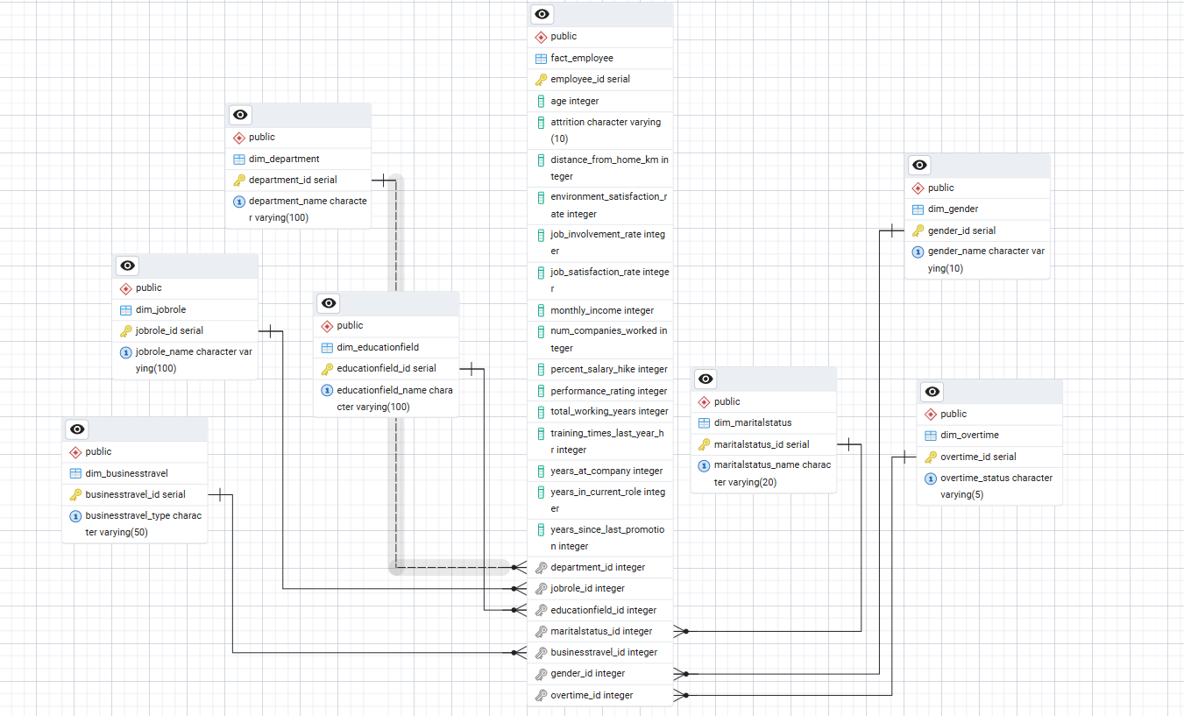

* The model follows a **1-to-many relationship** pattern:Each dimension table is related to many rows in the fact table.The foreign keys in the fact table reference the primary keys in dimension tables.This structure helps in simplifying complex queries, improving query performance, and ensuring data integrity.

🔷 **Category 1: Employee Performance & Compensation**

**1.What is the average monthly income by Job Role?**

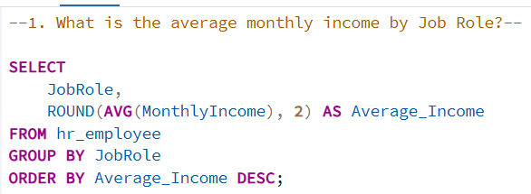

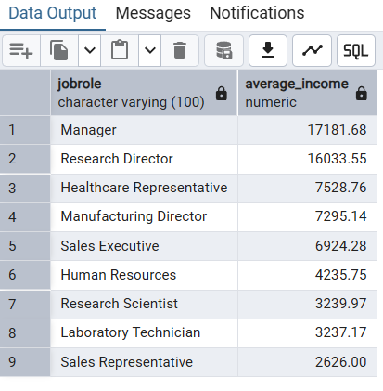

**Insight**

* Helps understand compensation trends across different job functions.
* Identifies potential pay gaps or overpaid roles.
* Assists HR in setting fair and competitive salaries for new hires.

2. **Which employees have high performance ratings but received below- average salary hikes?**

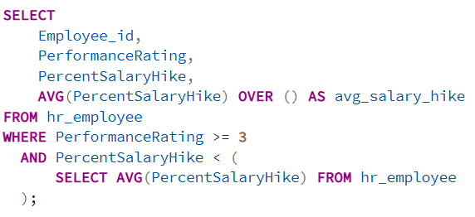

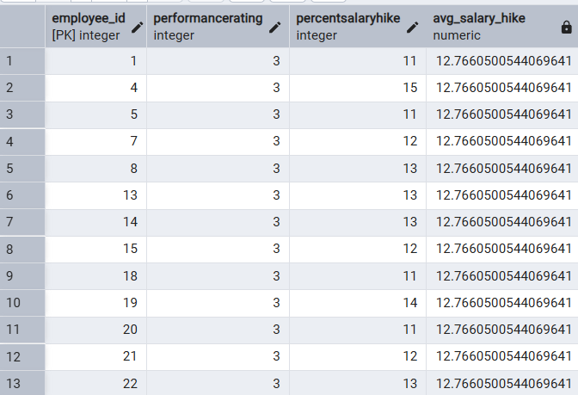

**Insight**

* Flags employees who may feel undervalued despite consistently strong contributions.
* Indicates potential dissatisfaction and increased risk of losing top-performing talent.
* Highlights the need to reassess and improve performance-based reward and appraisal systems.
* Only a small sample of the output is shown here — in reality, several employees meet this condition, making it a significant organizational concern.

**3. Find underpaid high performers in each department ?**

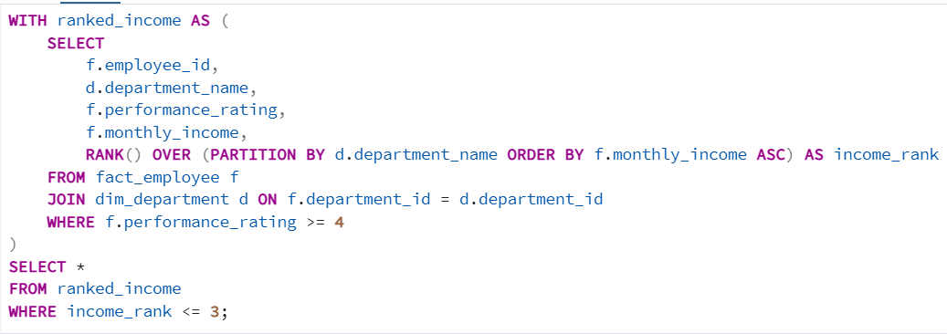

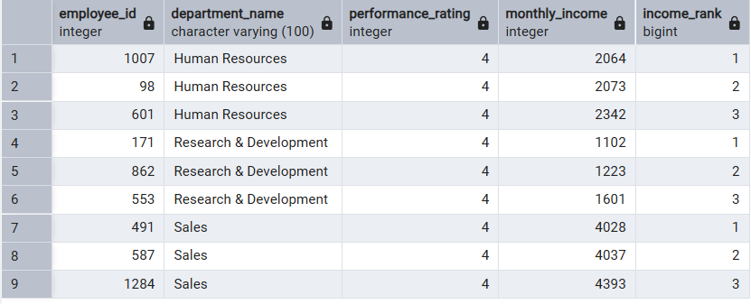

**Insight**

* Detects inconsistencies in internal compensation across departments.
* Supports equitable pay policies and targeted retention efforts.
* Helps ensure high performers are recognized and rewarded adequately

**4. Rank employees within job role based on performance (top-ranked only) ?**

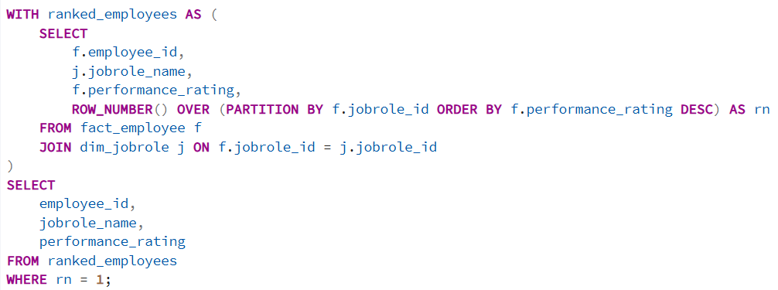

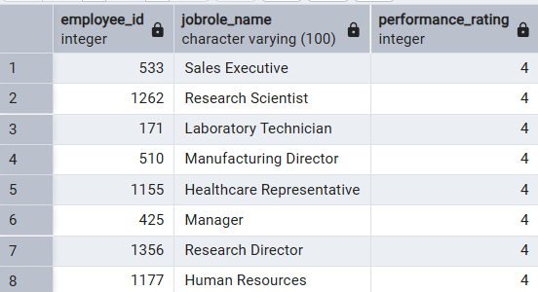

**Insight**

* Identifies the top-performing employee for each job role.
* Useful for building leadership pipelines or peer learning programs.
* Enables HR to reward excellence with recognition or promotions
* Reward them making them more valued

5. **Employees with long tenure but low perfomance ?**

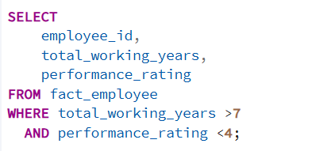

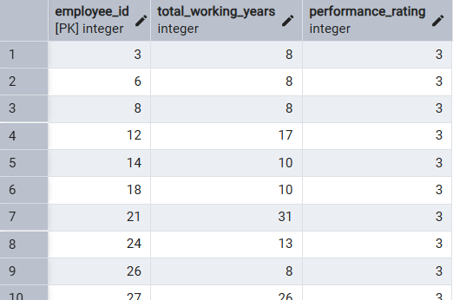

**insight**

* Highlights possible skill gaps or signs of disengagement among long-serving employees.
* Enables data-driven decisions on reskilling, upskilling, or assigning mentors to improve performance.
* Helps prevent long-term productivity decline and supports strategic workforce development.
* *Note: Only a subset of the employee data is displayed here — the actual number of affected employees is higher, reinforcing the importance of this analysis.*

🔷 **Category 2: Satisfaction, Promotion & Attrition Analysis**

6. **Attrition summary view with satisfaction scores**

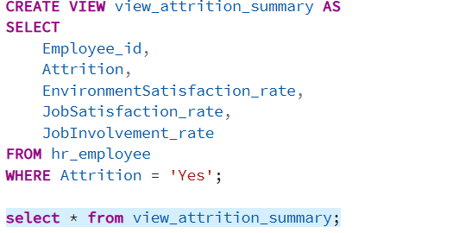

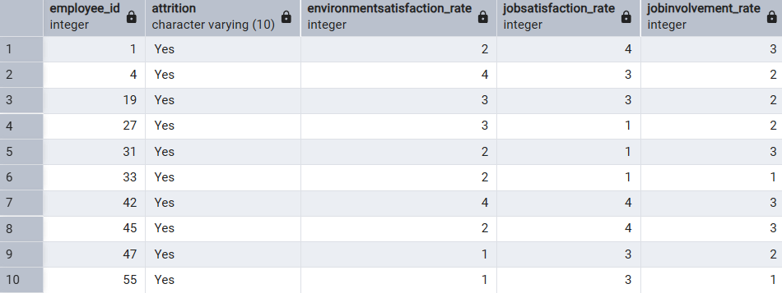

**Insight**

* Explores the relationship between employee satisfaction levels and attrition.
* Helps uncover whether low satisfaction is a driving factor behind resignations.
* Assists in forming a proactive employee retention strategy by focusing on improving work satisfaction.
* *Note: Only a few employee records are shown in the output — there are many more employees with similar patterns of satisfaction and attrition.*
* This analysis can support HR in prioritizing engagement initiatives and retention policies targeted at at-risk employee groups.

7. **Employees at risk (Low satisfaction + Overtime)**

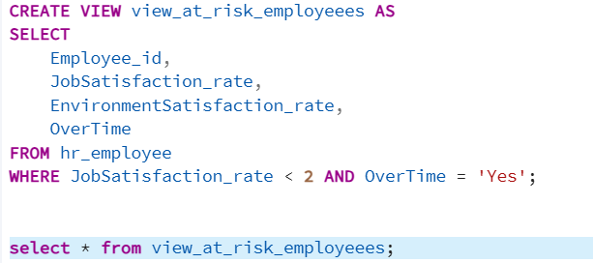

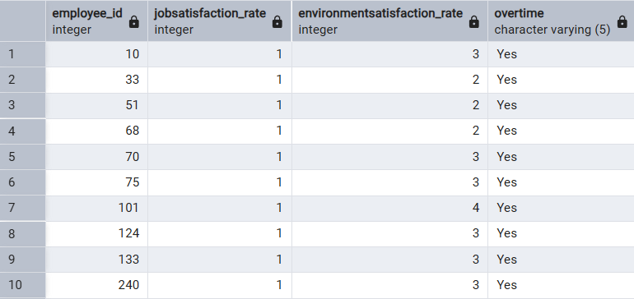

**Insight**

* Flags employees potentially facing burnout or disengagement due to prolonged overtime and low job satisfaction.
* Allows HR to intervene early, through check-ins, workload adjustments, or wellness programs, before these employees consider leaving.
* Aids in promoting a healthier work-life balance culture and reducing long-term attrition risks.
* ***Note: Only a few rows from the output are displayed here — in the full dataset, multiple employees meet this condition****.*
* These early signals can drive impactful retention and well-being policies across the organization.

**8.Employees not promoted in the last year**

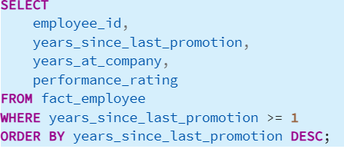

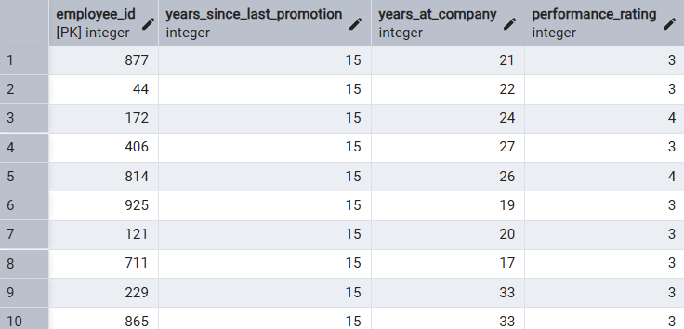

**insight**

* Indicates possible career stagnation or lack of internal mobility opportunities.
* These employees may feel overlooked or undervalued, which can lead to reduced morale and engagement.
* Helps HR teams identify candidates for promotions, training, or new roles to prevent disengagement and reduce churn.
* ***Note: Only a portion of the full data is shown here — many other employees fall into this category****.*
* Addressing this group proactively can strengthen talent retention and support leadership pipeline development.

**9.Employees with satisfaction below department average**

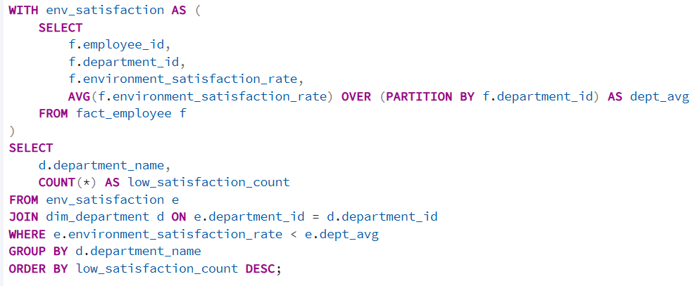

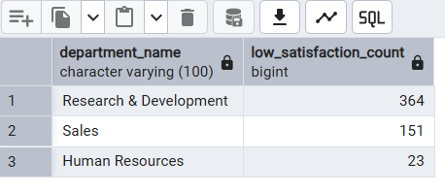

**Insight**

* Highlights departments that may be facing internal environment issues.
* Pinpoints team-level culture gaps requiring managerial attention.
* Enables targeted surveys or interventions to improve morale.

🔷 **Category 3: Retirement Planning & Workforce Readiness**

**10. How many employees are nearing retirement (Age ≥ 58) by department?**

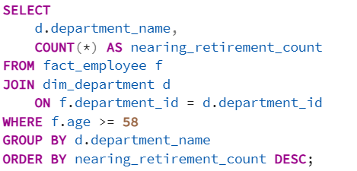

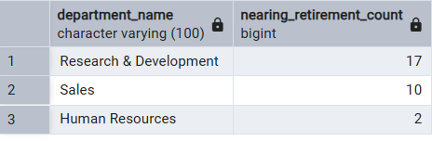

**insight**

* Reveals departments with a high percentage of older employees.
* Helps in planning for knowledge transfer and succession.
* Supports early hiring or training programs to avoid workforce gaps.

**11.Is there a need for hiring based on retirement risk?**

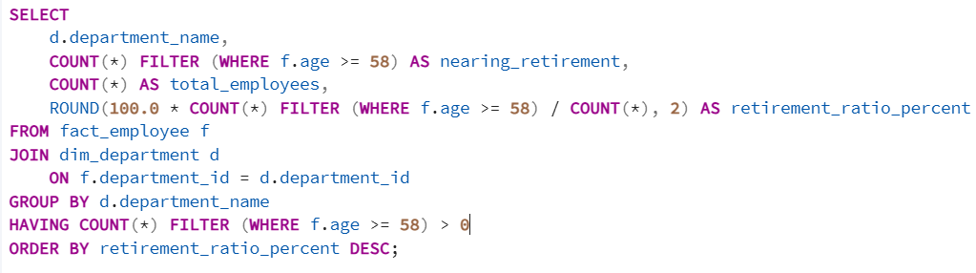

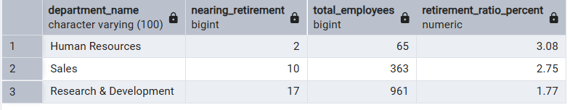

**Insight**

* Anticipates possible employee exits due to retirement.
* Enables proactive workforce planning and talent acquisition.
* Ensures continuity of operations and avoids last-minute hiring pressure.

**Category 1: Workforce Performance & Satisfaction**

**Insights:**

* Employees with high performance but low rewards indicate gaps in recognition systems.
* Long-tenured employees with low performance signal possible disengagement or outdated skill sets.
* Lack of promotion in recent years can lead to career stagnation and lower motivation.
* Employees working overtime with low satisfaction are at risk of burnout and attrition.

**Recommendations:**

* Revisit and align compensation policies with performance evaluation.
* Launch targeted learning and development programs for underperforming long-term staff.
* Implement transparent career progression frameworks and regular performance reviews.
* Introduce wellness and workload management strategies to reduce burnout.

**Category 2: Satisfaction, Promotion & Attrition Analysis**

**Insights:**

* Employees with low satisfaction rates are more likely to leave, as shown in the attrition summary view.
* Overtime combined with dissatisfaction is a common factor among resigned employees.
* Promotion delays and pay hikes below expectations are contributing factors to resignation decisions.

**Recommendations:**

* Conduct regular employee feedback surveys focused on satisfaction and work-life balance.
* Build a proactive retention model targeting at-risk employees using satisfaction and promotion data.
* Offer career mentoring and check-ins to employees who haven’t progressed in years.

**Category 3: Retirement Planning & Workforce Readine**

**Insights:**

* A sizable portion of the workforce is nearing retirement (age ≥ 58), requiring succession planning.
* Certain departments have aging employee concentrations, which may create future staffing gaps.
* Areas showing performance gaps or long stagnation may signal the need for hiring or restructuring.

**Recommendations:**

* Begin identifying and training successors for retirement-bound employees.
* Plan internal transfers or recruitment to replace roles likely to be vacated soon.
* Use workforce age demographics in conjunction with performance metrics to design future hiring strategy.

**CONCLUSION**

This HR analytics project, powered by structured SQL queries and dimensional modeling, has helped uncover patterns across employee performance, engagement, attrition, and succession planning. These insights provide a data-driven foundation for HR to design targeted strategies that improve retention, enhance employee experience, and prepare the organization for future workforce shifts.

By transforming raw HR data into actionable intelligence, this project demonstrates the real-world value of SQL and data analysis in human resource decision-making.